Hammond Regional Arts Center Building Use Policy

Rates:

 | Gallery and Kitchen* | Details
4 Hour Rental | $300.00 | Prices include use of tables, chairs and restroom facilities.
8 Hour Rental | $600.00 | Price includes use of tables chairs and restroom facilities.
- Security Deposit: 50% of the rental cost is due at time of booking in order to secure the building for a specific date. (Refundable up to 1 month prior to event. Non-refundable within 1 month prior.)
- Damage Deposit: A $100.00 damage deposit will be due at the beginning of each rental. It is refundable, dependant on the state of the HRAC at the end of the rental.
- Additional Time: Should you need additional time for your rental, it may be purchased at a rate of $75/hr. Additional time may be added in 1-hour blocks only.
- Cleaning Fee: Every rental will be charged a non-negotiable $75 cleaning deposit, due before the start of the rental.

Policy:

- Space can be booked up to 6 months in advance; availability will depend on the Hammond Regional Arts Center (HRAC) exhibition and event schedule.
- The Hammond Regional Arts Center is first and foremost an art gallery. Although it may be possible to move or reposition some individual pieces temporarily, under no circumstances will the HRAC agree to remove an exhibition from the gallery for an event. Please consider artistic freedom and content before booking the space.
- Renters are responsible for their own set-up (i.e. decorating, etc.) and clean-up (i.e. floors swept, trash taken to dumpster, etc.). A member of the HRAC staff or board of directors will be present during the hours covered during your rental agreement to answer questions and secure the building following the event.

- The back door must remain locked at all times due to safety precautions and insurance reasons. Leaving the back door unlocked or propped open is grounds for having building-use privileges revoked.
- The second floor and above is off limits to guests during rentals.

- No open flames will be permitted in the HRAC (the only exception is sterno cans under appropriate warming dishes).

- Grease and/or similar substances are not to be poured down sink drains under any circumstances. Please consider carefully when selecting menus and communicate with your catering staff accordingly, as this can impact the return of your damage deposit.

- If you surpass the ending time listed in your rental agreement, you will be charged accordingly for the extended use of the facility. Additional charges will be pro-rated based on the hourly rate of $75/hour and will be calculated in 15 minute increments. Please consider carefully your needs (including set-up and clean-up) before booking your event.

- Renter hereby indemnifies and holds harmless HRAC, its landlord, building owners, officers, directors, employees, and agents from any damages, actions, suits, claims, or other costs (including reasonable attorneys’ fees) arising out of or in connection with any damage to any property or any injury caused to any person (including death) caused by Renter’s use of the Space, specifically including but not limited to damages or injury related to the sale or service of alcohol, including any acts or omissions on the part of Renter, its employees, officers, directors, independent contractors, or other agents. Renter shall notify HRAC of any damage or injury of which is has knowledge in, to, or near the Space, regardless of the cause of such damage or injury.

Signature and Agreement: I have read and hereby agree to abide by the above policy.

___________________________________ ___________ ___________________________________ ___________
Renter's signature Date Gallery Representative's signature Date

Rental Agreement:

Name: _____________________________________________________________

Address: ___________________________________________________________

___________________________________________________________
___________________________________________________________

Phone #: ___________________________________________________________

Email Address: _______________________________________________________

Date of Rental: ____________Type:_______________________________________
(Restrictions may apply based on gallery exhibitions.)

Time (including setup): ___________ am/pm -- ___________ am/pm
Time of actual event: ____________am/pm -- _____________ am/pm
(Time restrictions may apply.)

Security Deposit: $_________________ due on _________________________________.
Damage Deposit: $__100.00__________ due on _________________________________.
Remaining Balance: $_________________ due on _________________________________.

Cleaning Fee: $_75.00________________ due on _________________________________.

Hammond Regional Arts Center Staff Use:
Security Deposit Rec'd: ______________________________
Damage Deposit Rec'd: ______________________________
Remaining Balance Rec'd: _____________________________
Cleaning Fee Rec’d: __________________________________

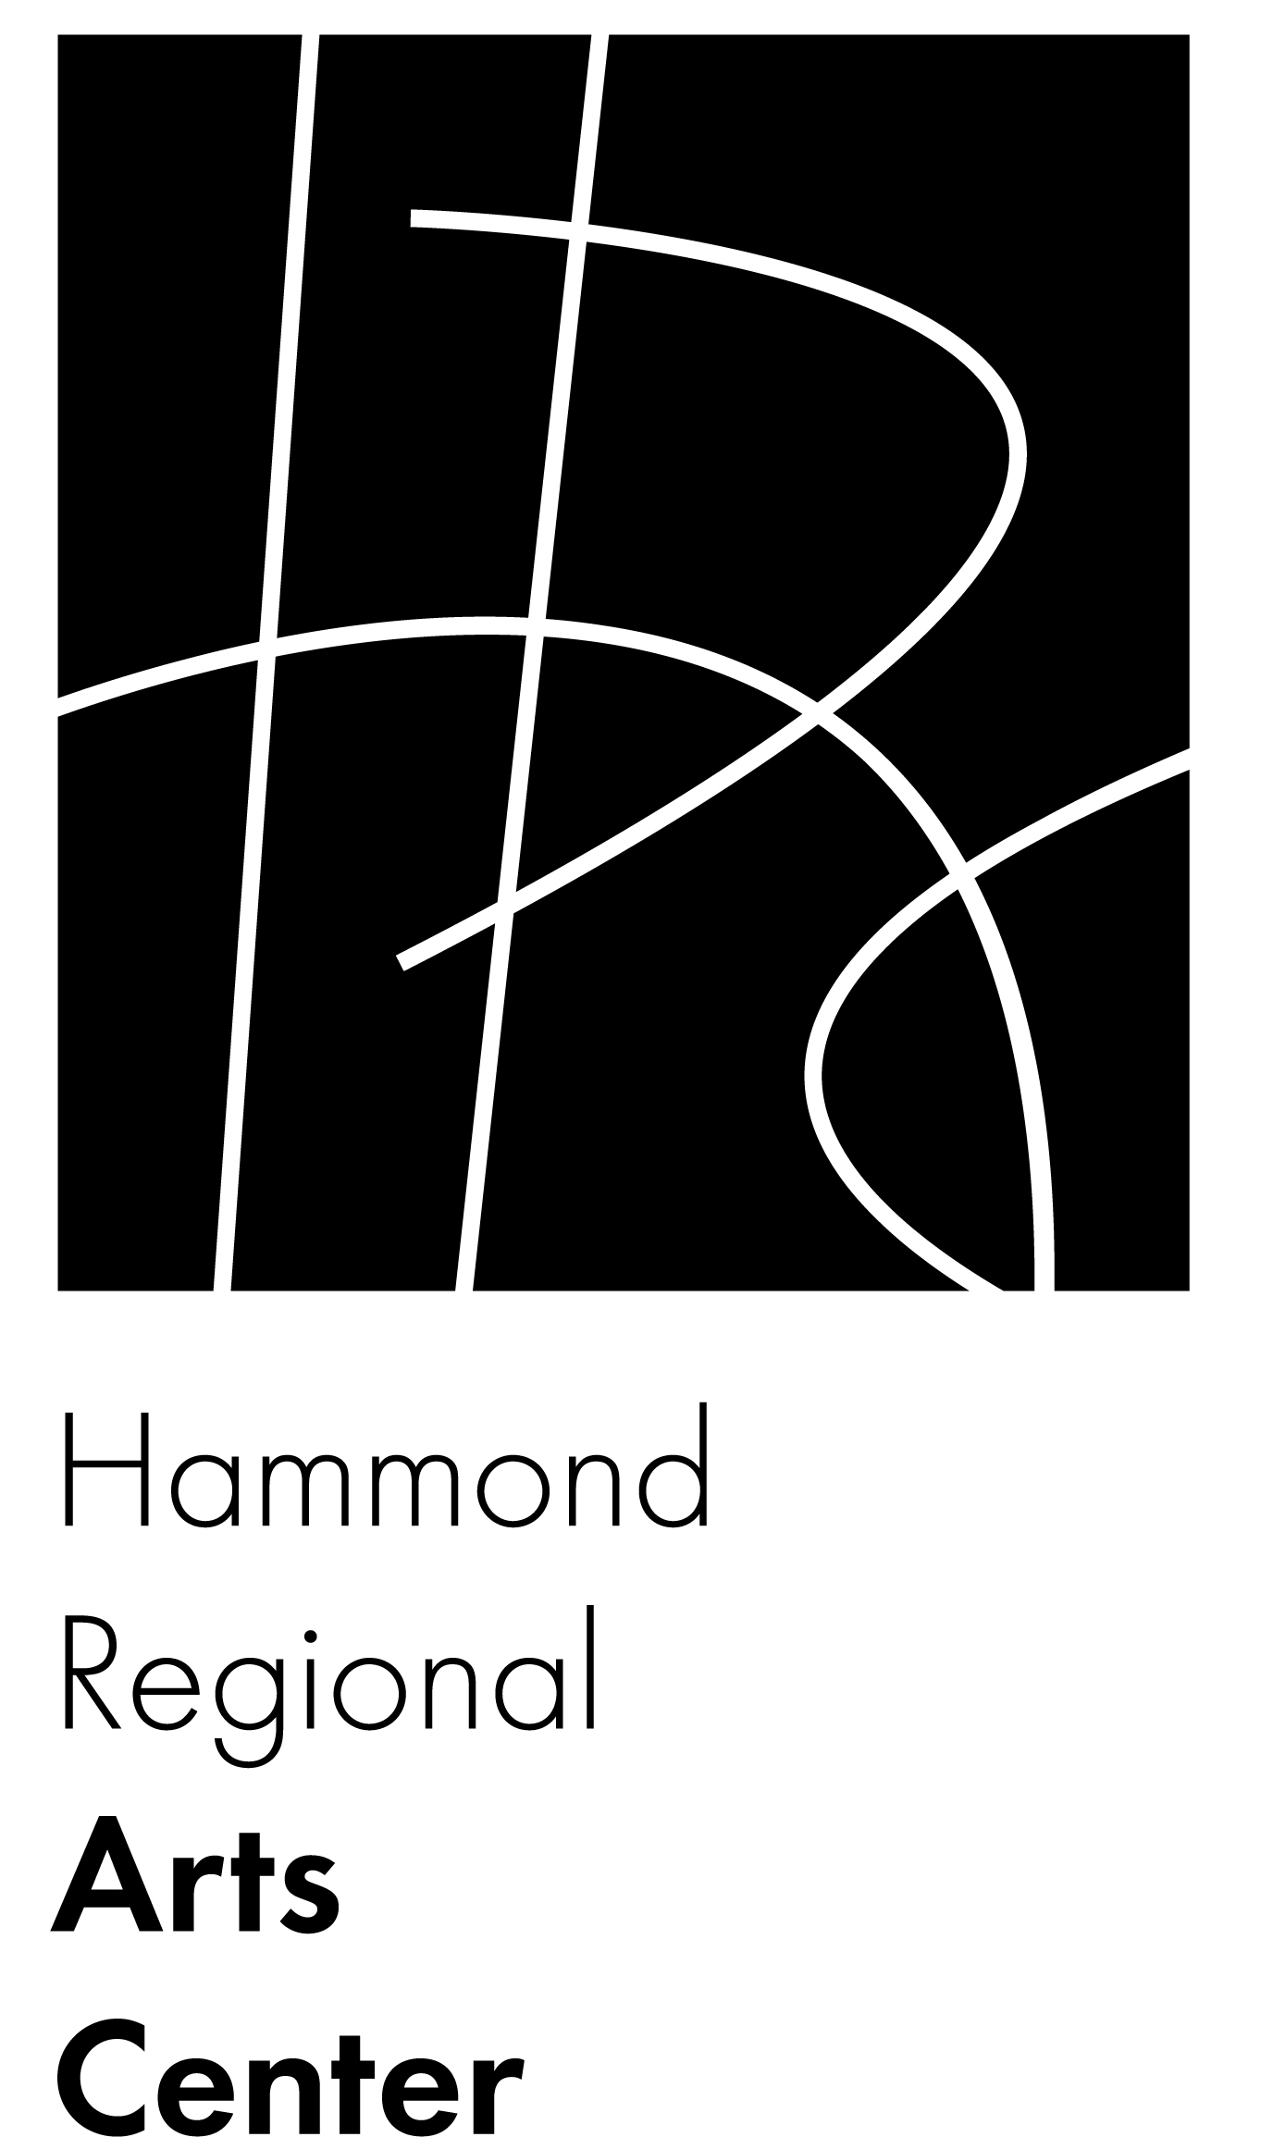
P.O. Box 2974
217 E. Thomas St.
Hammond, LA 70404
(985) 542-7113
info@hammondarts.com
www.hammondarts.com

